Four Cs
Multi-Academy Trust

POLICY FOR
MATERNITY AND PATERNITY LEAVE

Presented to
Trustees
21 March 2018

Date approved:¹ | 21 March 2018 (adopted)  Trustees Standards Committee
Consultation: | Union and Staff Consultation  1 May 2018 – Completed
Date reviewed:²
Date of next review:³ | Spring 2021

This is the date the policy was approved by the meeting
² This is the date the policy was reviewed prior to its approval above
³ This is the date as set by the policy review clause or the date approved plus two years

POLICY FOR MATERNITY AND PATERNITY LEAVE

Item | Description | Page
1.0 | Maternity - Teaching Staff Entitlement and Application Form | 3 - 4
2.0 | Maternity - Support Staff Entitlement and Application Form | 5 - 6
3.0 | Paternity | 7 - 8
4.0 | Paternity Application Form | 9 - 11

1.0 TEACHING STAFF MATERNITY ENTITLEMENT (PCC)
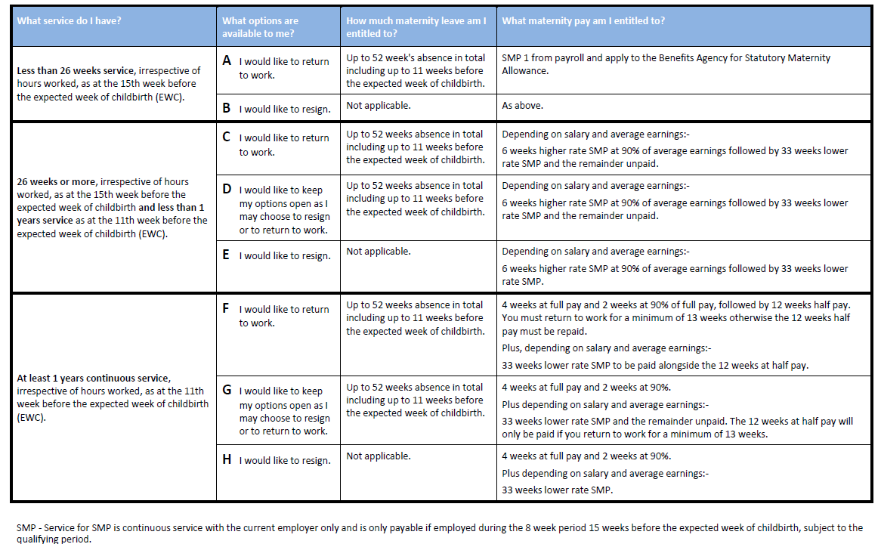

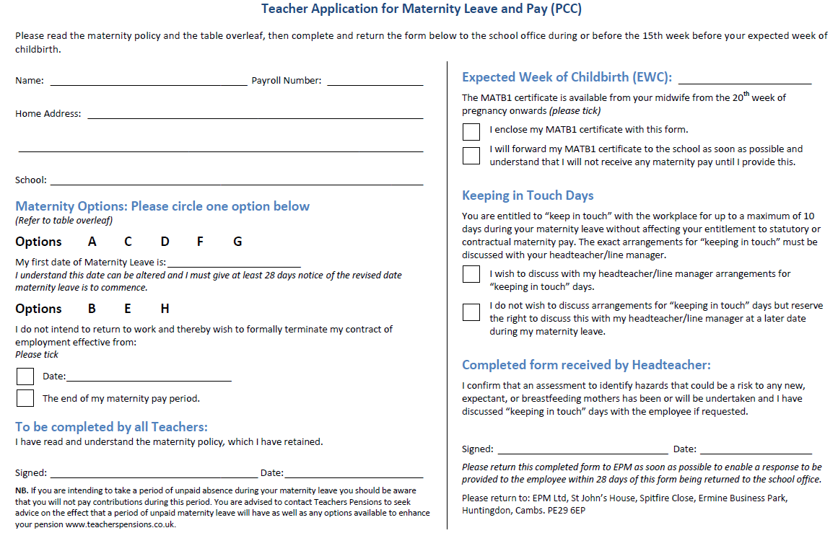

2.0 SUPPORT STAFF MATERNITY ENTITLEMENT (PCC)
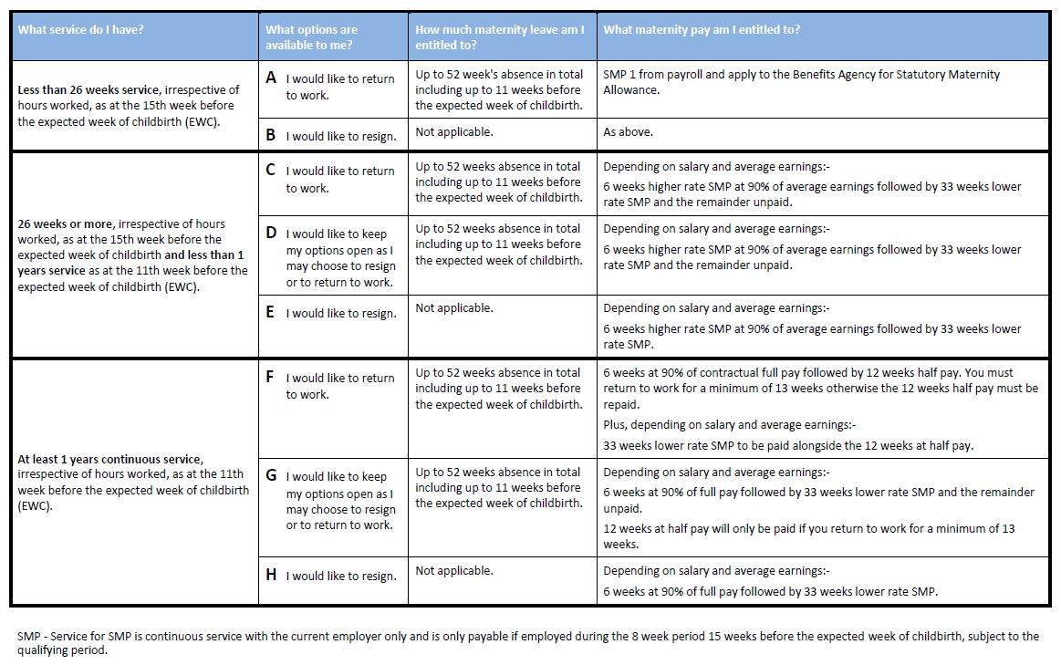
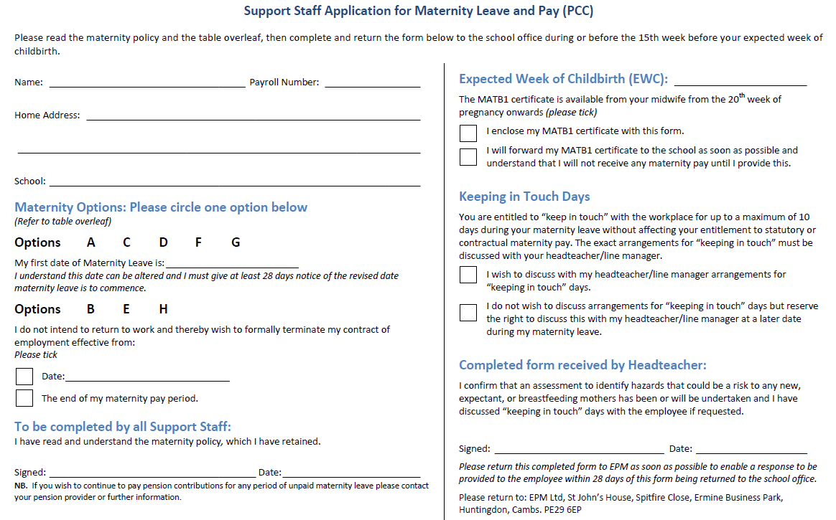

4.0 PATERNITY

The information detailed in this section is statutory guidance available on the Gov.Uk website (https://www.gov.uk/employers-paternity-pay-leave).

  - Entitlement

Employees may be eligible for Statutory Paternity Leave and Pay if they and their partner are:
  - having a baby
  - adopting a child
  - having a baby through a surrogacy arrangement

  - Statutory Paternity Leave

Employees can choose to take either 1 week or 2 consecutive weeks’ leave. The amount of time is the same even if they have more than one child (eg twins).

Leave can’t start before the birth. The start date must be one of the following:

- the actual date of birth
- an agreed number of days after the birth
- an agreed number of days after the expected week of childbirth

Leave must finish within 56 days of the birth (or due date if the baby is early). The start and end dates are different if the employee is adopting.

  - Statutory Paternity Pay

Statutory Paternity Pay for eligible employees is either £140.98 a week (as at February 2018) or 90% of their average weekly earnings (whichever is lower). Tax and National Insurance need to be deducted.

  - Extra Leave Or Pay

Employees can get more leave or pay if:

- their partner returns to work and they qualify for Shared Parental Leave and Pay
- your company scheme offers more

You must make sure your paternity leave and pay policies are clear and easily accessible to staff.

  - Leave For Antenatal Appointments

Employees can take unpaid leave to accompany a pregnant woman to antenatal appointments if they are:

- the baby’s father
- the expectant mother’s spouse or civil partner
- in a long term relationship with the expectant mother
- the intended parent (if they’re having a baby through a surrogacy arrangement)

They can accompany the woman to 2 appointments of up to 6 and a half hours each.

  - If The Baby Dies

Employees still qualify for paternity leave and pay if the baby is either:
- stillborn from 24 weeks of pregnancy
- born alive at any point in the pregnancy but later dies

  - Employment Rights

An employee’s employment rights (like the right to pay, holidays and returning to a job) are protected during paternity leave. The MAT will still have to pay Statutory Paternity Pay even if it stops trading.

  - Eligibility

Employees must:
- have worked for you continuously for at least 26 weeks by the end of the 15th week before the expected week of childbirth (known as the ‘qualifying week’)
- be classed as an employee (paternity leave only)
- be employed by you up to the date the child is born (or placed with the adopter) (paternity pay only)
- be on your payroll and earn at least £113 a week (gross) (as at February 2018) in an 8 week ‘relevant period’ (paternity pay only)
- give you the correct notice
- be taking time off to look after the child or their partner
- be responsible for the child’s upbringing

The qualifying week is different if the employee is adopting. They must also be one of the following, the:

- father
- husband or partner of the mother (or adopter)
- child’s adopter
- intended parent (if they’re having a baby through a surrogacy arrangement)

There are special rules for some employee situations, eg if they leave or become sick.

